**Lab 3:**

**System Calls for Basic Process Management**

1. **ls**

**mkdir process**

**cd process**

**nano basic.c**

**Text from nano window:**

#include <stdio.h>

#include <time.h>

#include <unistd.h>

int main(){

float pi;

pi=3.1415;

printf("\n The value of pi is %.4f\n",pi);

return 0;

}

**Press ctrl+x to save file.**

**gcc -o basic basic.c**

**./basic**

**Interpretation:**

A simple C program for printing a constant value.

**Output:**

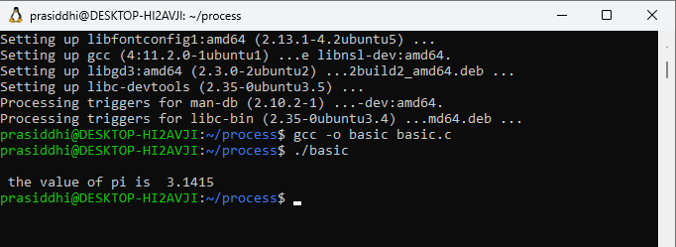

1. **nano fork.c**

**Text in nano window**

#include <stdio.h>

#include <sys/types.h>

#include <unistd.h>

int main()

{

// make two process which run same

// program after this instruction

if(fork()==0){

printf("I am a child.\n");

}

else {

printf("I am the parent.\n");

}

printf("Hello!\n");

return 0;

}

**Press ctrl+x to save file.**

**gcc -o fork fork.c**

**./fork**

**Interpretation:**

A program for creating child process from a parent process using function fork().

**Output:**

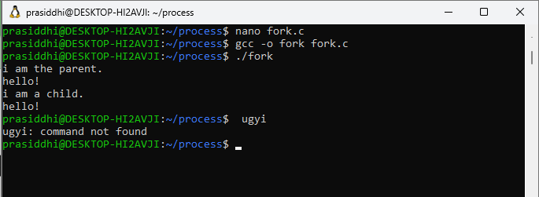

1. **nano pid.c**

**Text in nano window**

#include <stdio.h>

#include <unistd.h> //contains fork prototype

int main()

{

int pid,pid2;

pid = fork();

if (pid == 0)

{

printf("\nChild Process id : %d",getpid());

printf("\nChild Process with parent id : %d \n",getppid());

}

pid2=fork();

if(pid2==0){

printf("\nChild Process id : %d",getpid());

printf("\nChild Process with parent id : %d \n",getppid());

}

return 0;

}

**Press ctrl+x to save file.**

**gcc -o pid pid.c**

**./pid**

**Interpretation:**

A simple program for demontration of fork() function which is used to create

a child process from parent process.

**Output:**

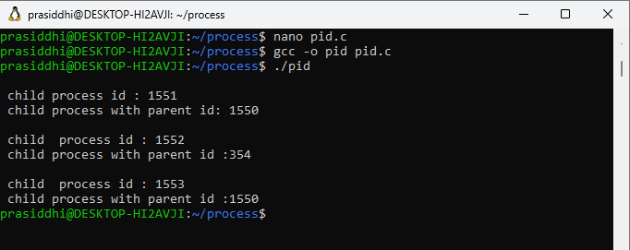

1. **nano execute.c**

**Text in nano window.**

#include<stdio.h>

#include<stdlib.h>

#include<unistd.h>

int main() {

char *temp[] = {NULL,"hello","world",NULL};

temp[0]="basic";

if(fork()==0){

printf("I am a child process.\n");

printf("My id is: %d\n",getpid());

printf("My parent is: %d\n",getppid());

printf("I am going to execute a c program\n");

execve("basic",temp,NULL);

}

else{

printf("The id of current process is %d\n",getpid());

}

return 0;

}

**Press ctrl+x to save file.**

**gcc -o execute execute.c**

**./execute**

**Interpretation:**

A program for demonstrating execve() function which causes the program that is currently being run by the calling process to be replaced with a new program, with newly initialized stack, heap, and (initialized and uninitialized) data segments.

**Output:**

